Chapter 3
Application’s Database
Database
The most important part of an application is the database. In fact all the operations done on an application are based on the database. A database which is designed by considering all conditions and contains comprehensive number of fields, increases the sufficiency of the process.
Projects (ProjectsTable) and Persons (PersonsTable):
This table as mentioned earlier is one of the most important tables of the software so that tables such as Persons, Salary and several other tables are subset of this table.
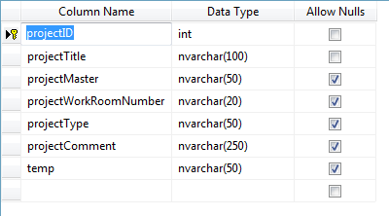
As you can see this table have ID field.
This field in other tables is a Foreign-Key field. Like in Persons table:
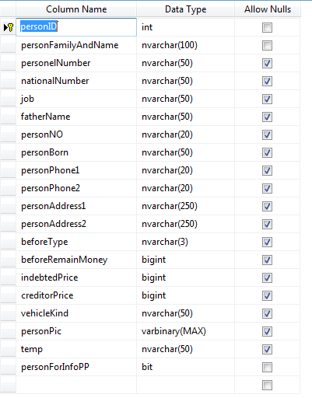

The relationship between projects table is ∞ to ∞ as each person can participate in many projects and each project can be used by many persons.
Therefore it must be a third table that provide us this relationship.
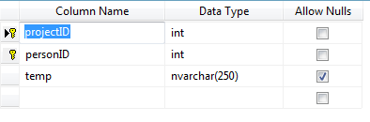

The relationship for this three table is like:
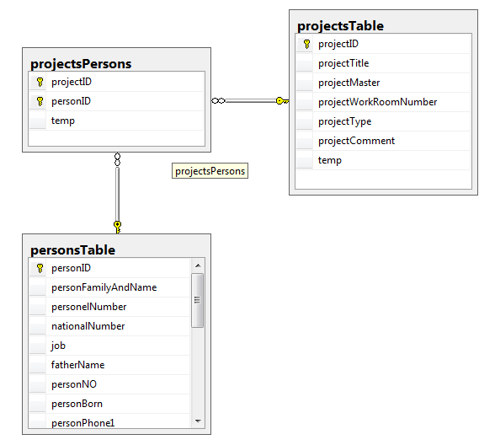
As you can see the relation between the three tables is made by two Keys:
- projecteID
- personID
Accounting Documents (AccountingDocs)
One of the most important and crucial tables in the software is the Accounting Documents table.
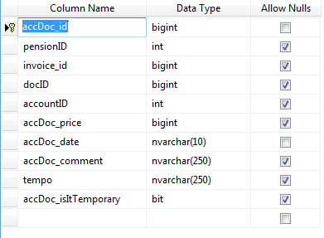
In this table the Accounting Document itself is stored. Accounting documents fields are:
- Accounting Document No. (Key-Field)
- Accounting Document Date
- Accounting Document Fee
- Accounting Document Description
- Accounting Document Type (Permanent or Temporary)

All Accounting Document have a similar form:
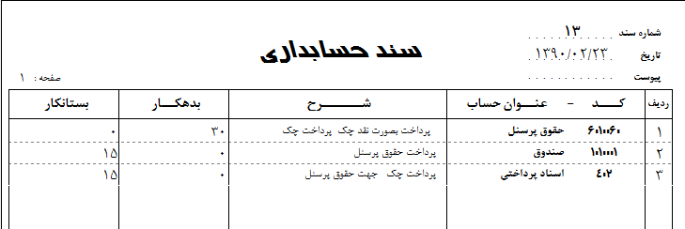
An Accounting Document have following properties:
- Row number
- Chart of accounts code
- Charts of accounts title
- Description
- Debtor
- Creditor
We should consider each one of these properties as individual field. Thus in order to store an Accounting Document’s rows there is a need for another table:
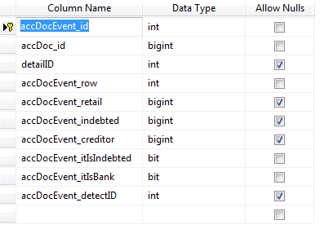
This Table is used for storing Accounting Document’s rows. In fact an accounting doc can have an infinite number of rows thus the relationship between these two tables is 1 to ∞.
To create this relation we have to use AccDocc_id field:
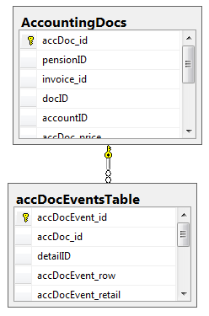

Charts of accounts (spentMaster, detailsTable)
As mentioned earlier, one of the Accounting document statistics is charts of accounts. These charts are:
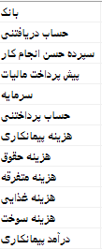
These Titles are the super (upper level) titles. It means these title have their own subset titles which called subsidiary titles.
We stored the super titles in a table with a name “SpentsMaster”:
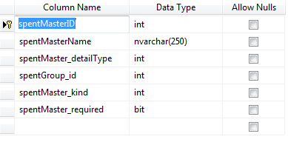
The Key-Field as the figure describes is named spentMasterID. By using this key, we create a one-to-many relation into subsidiary table. This table is as follows:
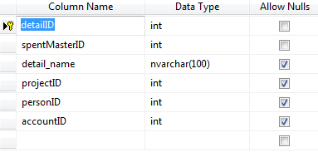
The relation is like:
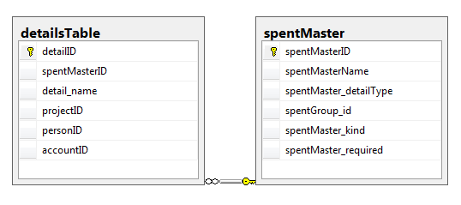

Bank Accounts (AccountsTable) and Cheques (ChecquesTable):
Banks accounts of contact companies are stored in Bank_Account table and cheques are stored in cheques-related table.
Bank Accounts:
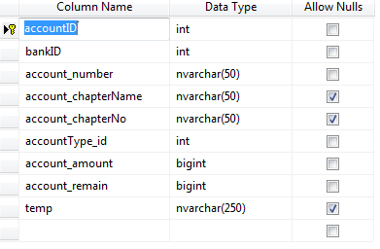
The key field of this table is accountID. There is a field named BankID in this table which is foreign key. This field creates a relation between banks and table of bank accounts. It is obvious that each bank can have multiple account. For example I have to accounts in two different banks. The banks table is like:
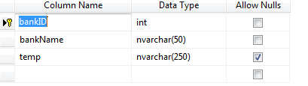
Information of this table are pre-entered and the end-user only allowed to append to them:
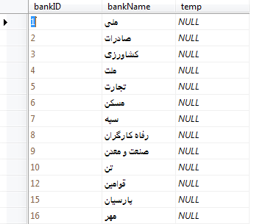
Cheques table is like:
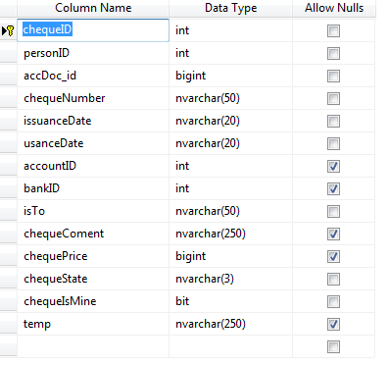
As it demonstrated cheques table is in relation with three table at a time:
- Accounting Documents Table
- Persons Table
- Bank Accounts Table
Therefore it cannot be in relationship with the above tables at the same time. The relation of four banks, bank’s accounts, cheques and persons is like:
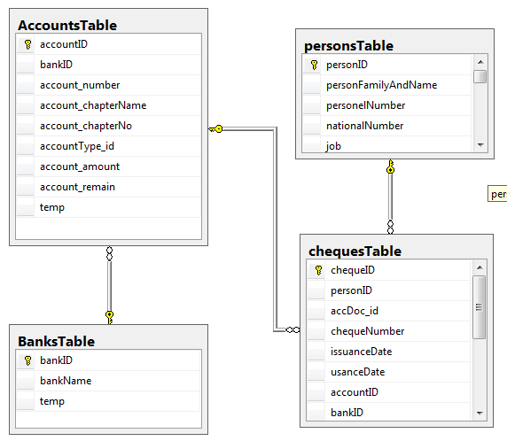

Salaray Paper (pensionsTable):
Salary receipt papers are been delivered to the employees and workers in an active project.
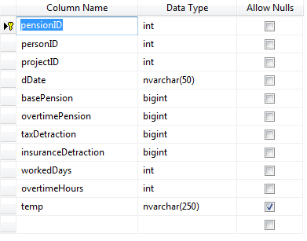
The Key-Field of this table is pensionID. For each salary receipt can define Benefits and deductions. It means each salary receipt can have infinite number of them. These items are used to calculate the pure salary of each employee and worker. The table in which Benefits and deductions are store is like:
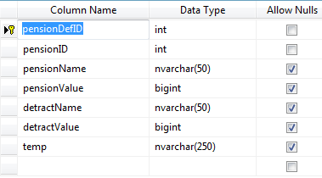
The two pensionName and pensionValue fields are used to define Benefits whereas detractName and detractValue are used for deductions definition.
It is certain that the relation between these latest mentioned tables is created with pensionID.

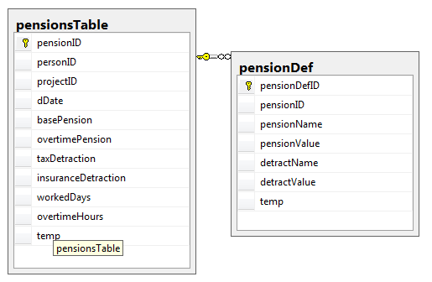

Leave sheets (freeFormsTable):
Leave sheets are just stored in this table:
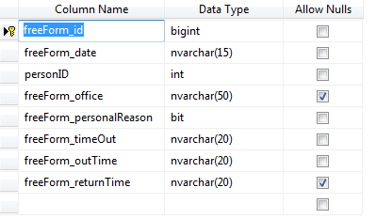
This table have One-To-Many relationship with Persons table:
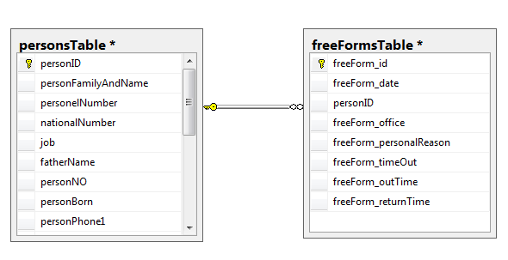
Every person can have more than one leave sheet.

User-Account table (usersTable):
End-users are playing an important role in the software. Users are capable of changing the way that the software used, change the app appearance and access levels. Every user can define a user-account for him/herself or for others. There are four types of users can be defined:
- Developer: has full access to the software and database.
- Manager: has full access to the software and no database access.
- Normal: has partly access to the software and no database access
- Limited: Read-Only few access to the software and no database access.
Users Table is like:
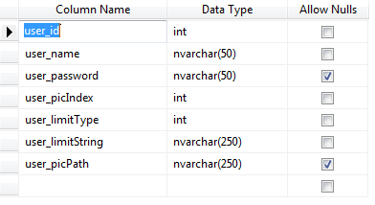
Entire user information is stored in this table. Information such as passwords, user types, photos and permissions.

